Predulive Edutech Foundation

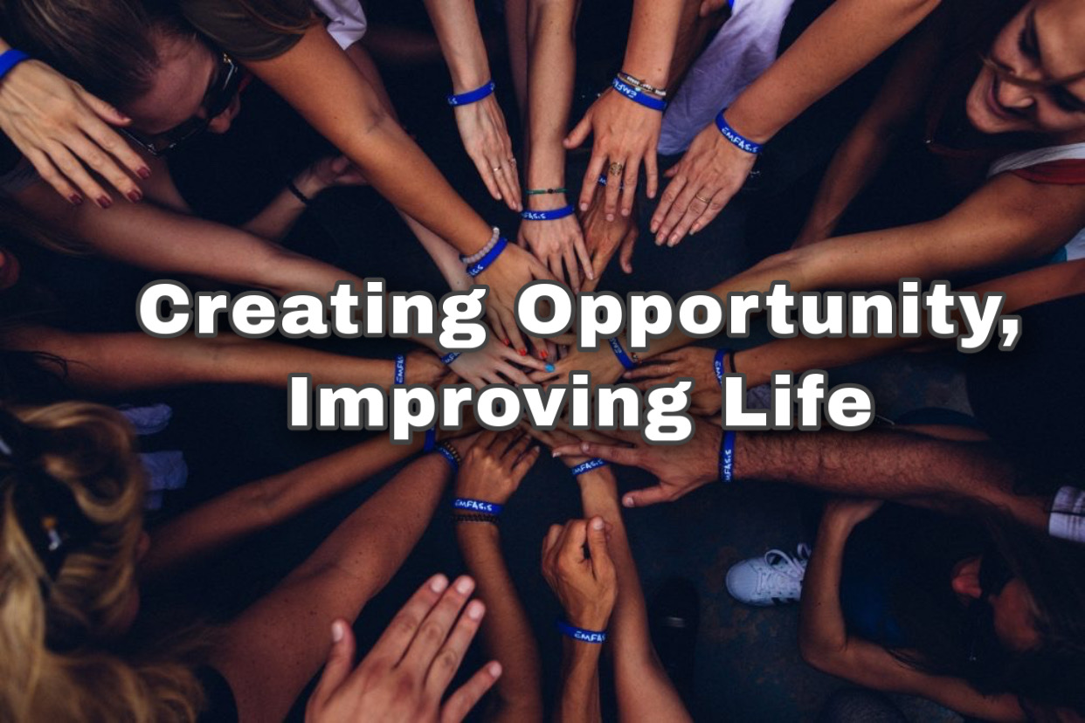

Our Services Catalogue

ABOUT PREDULIVE EDUTECH FOUNDATION:

Predulive Edutech Foundation’s primary mission is to inspire, aware, educate & employ by driving large-scale job creation through entrepreneurship, innovation and skills development.

The youth, especially, those living in the rural areas are unaware of the new job opportunities. The lack of appropriate training and no proper formal education in small towns and cities are also some of the reasons for unemployment. So that Predulive provide an opportunity to discover their capabilities an encouraging environment to grow through various training & workshops in the field such as electronics, telecom, agriculture, Aviation, BFSI retail, healthcare, tourism & hospitality. With a lot of employers complaining about the lack of requisite skills in new entrants, Predulive aim is to offer skill training to the youth and make them industry ready.

When it is hard to afford necessities like food, shelter, and clothing; education becomes a luxury that the poor give up. Illiteracy then leads to further poverty. UNESCO declared that the Indian Education system is behind by 50 years for the 2030 Sustainable Development goals. Even after development and successful implementation of Education models around the world, Indian education relies heavily on traditional teaching methods involving rote memorization and similar testing methods.

Predulive Edutech Foundation, through the implementation of project based learning and hands-on activities, hopes to bring back the joy in learning. With the use of innovative approaches to teaching, they hope to ignite the spark of curiosity in children and gently chisel them to take form befitting the world standard.

Predulive always try to Collaborate with multiple startups of different -2 industries like Drones, Medical & Agriculture etc. for building a good ecosystem for our youth & our unemployed workers.

OUR WORK

1. Career Counselling Sessions:

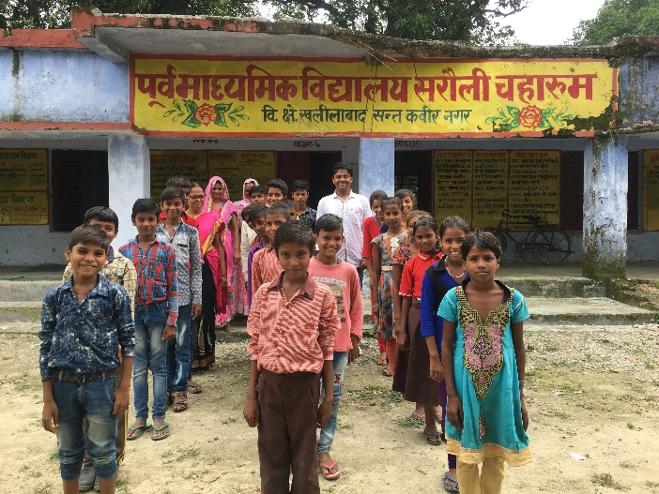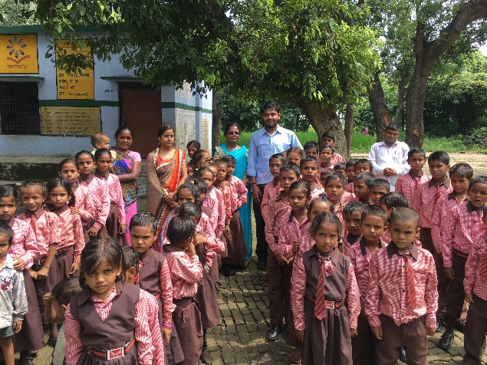

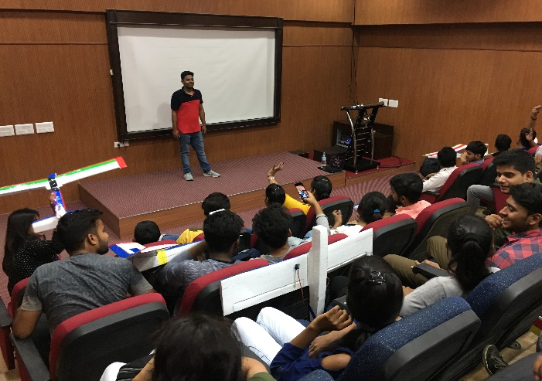

Career Counselling is the pivotal cog in a student’s journey. A good career counsellor makes the perfect roadmap for students and based on which they can achieve their goals. Predulive provide a great counsellor which can give the right direction to the child alongside advice the parents to take up progressive decisions.

Predulive Counsellors Conduct counselling sessions through following process flow:

### Building Awareness:

Great readers become great counsellor and great motivators. A career counsellor is a teacher and a motivator, so building awareness about different career fields and prospects add value to the counselling profession. Predulive Career Counsellors can up their ante with this course and they will have answers to all the possible questions asked by students.

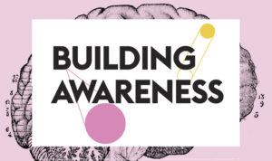

### Assessment:

### Once a Student walks in for career counselling, as a best practice, put him/her on a psychometric assessment to dig deeper into the personality. In this way, the career counsellor knows the abilities and interests of the person.

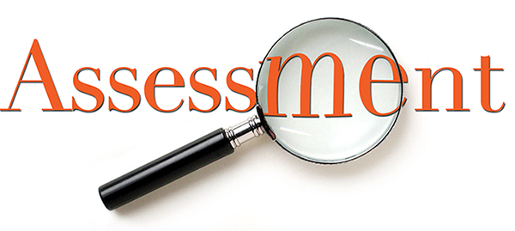  
 Once the results of the assessment are out, they give clarity to the students, and the career counsellor can offer expert guidance accordingly.

* Right Career Choices:

The next step in career counselling is to provide ample choices to the students based on their personality assessment. The career counsellors will link the attributes of a student to the available career options to create a personalized roadmap.



Career counsellors can take one-on-one sessions to discuss various factors affecting choices in alignment with future prospects.

* Planning the College Journey:

Now the dream college has been identified and different backup options are also listed. The next step is advising on the entrance examinations and advocating the need for **Profile building**.

The hallmark of career counselling is offering personalized student roadmap for success. The career counsellors have to achieve this by a keen understanding of the student profile over multiple interactions. The career counselling process should take an unbiased approach. That puts the students in a better position to make life-changing decisions.

1. Workshops & Training for Youth:

Predulive has the mission of providing industrial training to facilitate skill-building for the various sectors like Aero, Drones, Robotics, Electronics, Machine Learning, Design, etc. We have conducted several training programs in the field of Aeromodelling, Robotics and Electronics all over India.

Our workshops & Trainings have been designed by engineers and professional hobbyists with over four years of experience in the field. We organize two types of workshops & trainings:

1. Aeromodelling:

**“In this programme, children get a chance to build model airplanes, gliders, birds, rockets and fly them. They get an idea of what an aircraft is really about and the ‘hands on’ experience on Aeromodelling kits, Flight Simulators, audio-visual shows, experiments, projects, activities bringing them closer to science and aviation.”**

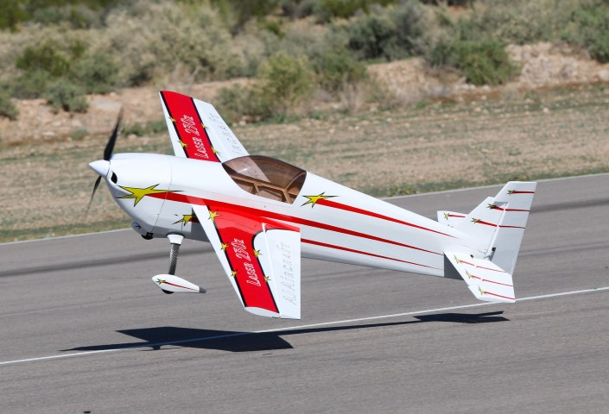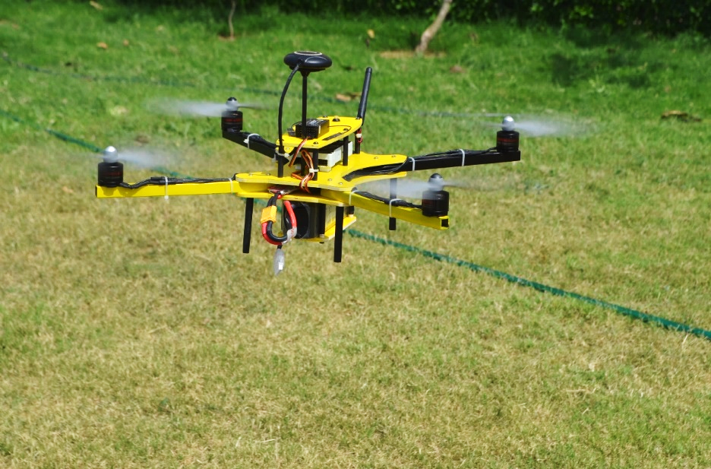

Quadrotor Drone

Trainer Aircrafts

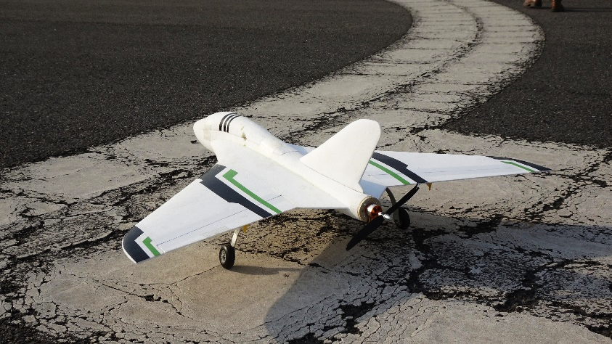

Delta Flying Wing Aircrafts

2. Robotics

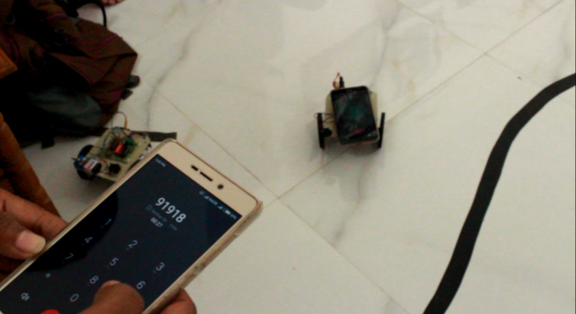Robotics and automation are one of the growing industries and have lot of potential in future. Students who join early would definitely have an advantage in terms of hands-on experience they get in their career when industry is starting to grow.

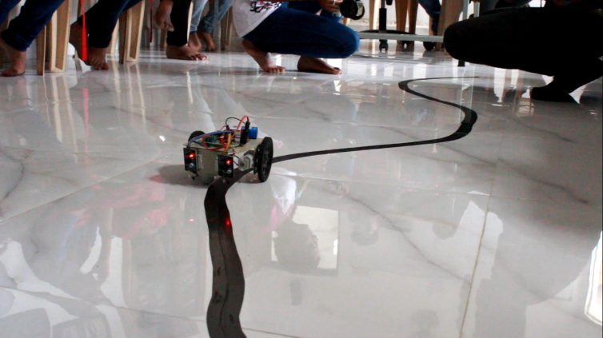

**Line Follower & Smartphone Control Robot**

By these innovative workshops & trainings, Predulive try to create more employment in rural areas.

1. Startup Meetups:

"Entrepreneurs are excited to be part of something that is growing and becoming grand, so tap into those desires by helping us create relationships with other dreamers, people we can share with, learn from and with whom we can explore new possibilities in our meetup programs. Focus less on being cool and more on being human."

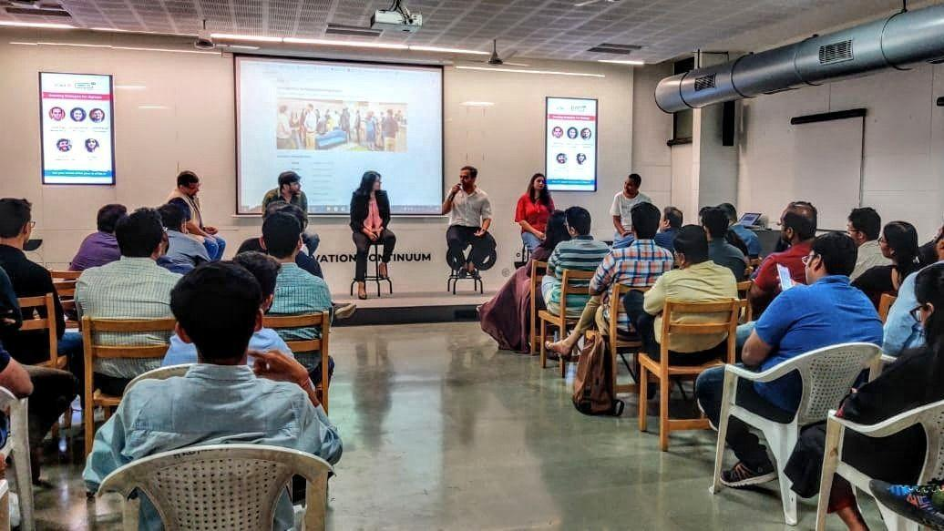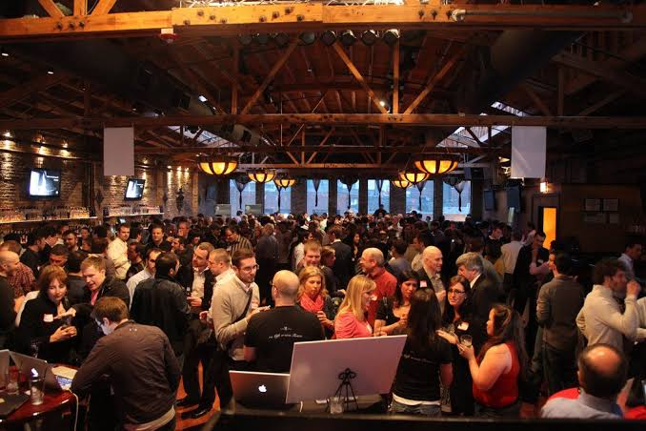

Predulive organize a startup meetup programs in small rural areas & provide an opportunity to young budding entrepreneurs of small towns to showcase their ideas & find some guidance by an industry expert.

1. Rural Development Career Awareness Expo:

The purpose of the Career Expo was to expose the rural youth to various career path opportunities which will in turn motivate them and contribute towards addressing the current unemployment areas. The Rural Development Career Awareness Expo’s serves excellent youth empowerment initiative and information sharing platform for private companies as well as tertiary Institutions.

We aim to create educational, uplifting, empowering and sustainable Youth Development Initiatives in our district. Our Organization is made up of passionate and dynamic torch bearers who are driven to achieving the quest to realize economic empowerment and social upliftment and development in our communities.

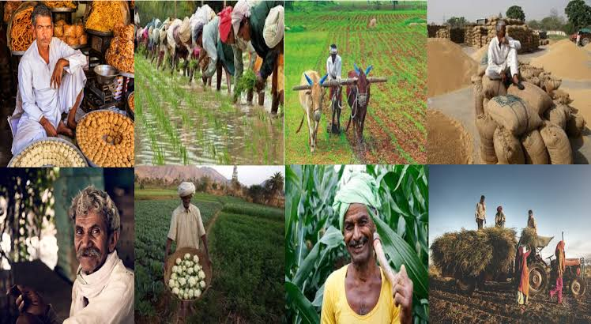

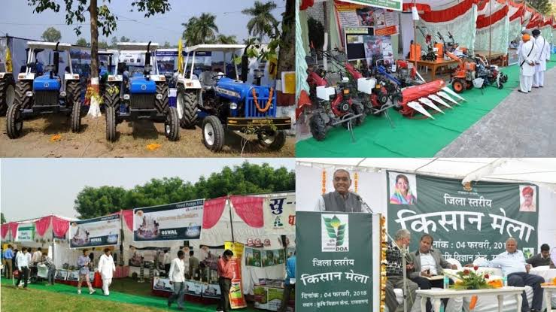

Rural Career Expo Objectives

* The main objective of the expo was to create career awareness campaign

focusing on scarce skills. We aim to provide a vehicle to disseminate information.

* To provide a platform for creating more access to various career options for the rural communities and youth.
* We aim to strengthen the linkages between schools, colleges, local communities and businesses. We intend to explore the innovative channels that will strengthen the relationship between College, Local Communities, Private Companies & Consultants.
* Delegates received comprehensive presentations and information on various

career opportunities.

Thank You!